Planets Database

AIM:
To write a Prolog program to create a database of planets and retrieve informatian about them.

ALGORITHMS:
- Start.
- Define facts containing planet names and their properties.
- Create rules to retrieve planet information.
- Query the database for a particular planet.
- Display the corresponding details.
- Stop.

CODE:

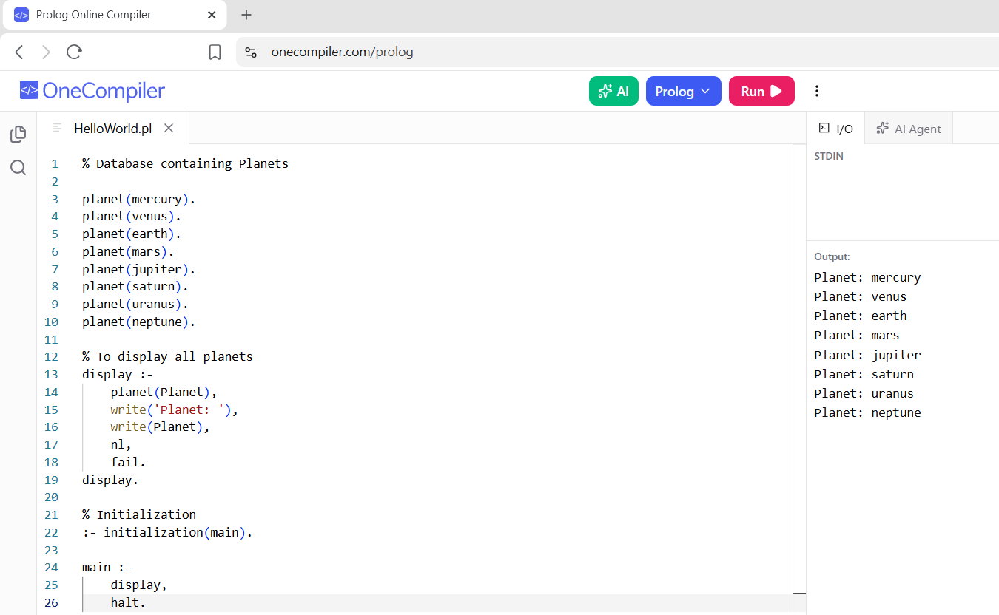

RESULTS:
The details of the requested planet are retrieved and displayed successfully.

